**Data Analysis Report (act_report)**



Dogs are one of the most loved home pets that someone could ever have. It is believed that there is a total of 76,811,305 dog in the US only. This show how popular dogs are and how much people adore and trust them.

After cleaning the [@dog_rates](https://twitter.com/dog_rates) twitter data, some interesting insights can be drawn from the data. I have found four as follows:

***Insight 1***

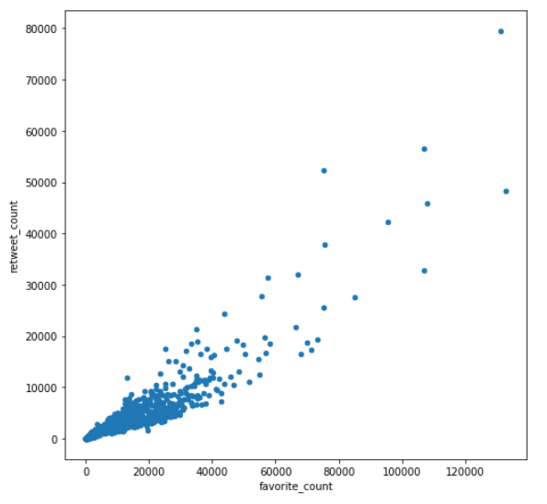

From the above graph we can see a strong positive correlation between the *favorite_count* and *retweet_count*. I don’t have a Twitter account, but I guess this is expected since more retweets means more popularity, hence more like and favorite.

***Insight 2***

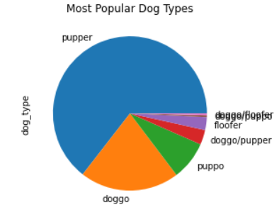

From the above pie-chart we can clearly see that according to this dataset pupper is the most common dog type followed by a large margin by doggo.

***Insight 3***

From the results of the three prediction algorithms, we can suggest that the most common dog breeds in this tweets archive are *Labrador Retriever* and *Golden Retriever*. This is likely to be true since according to [www.ack.org](http://www.ack.org) the most common dog breed in the US is *Labrador Retriever.*

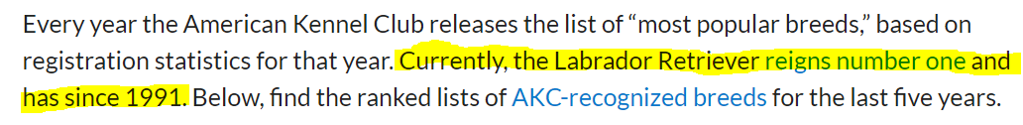

From [www.ack.org](http://www.ack.org)

***Insight 4***

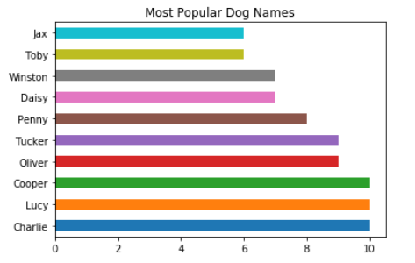

According to this dataset Charlie, Lucy, and Cooper are the most common dog names. By doing a simple Google research I found out the following:

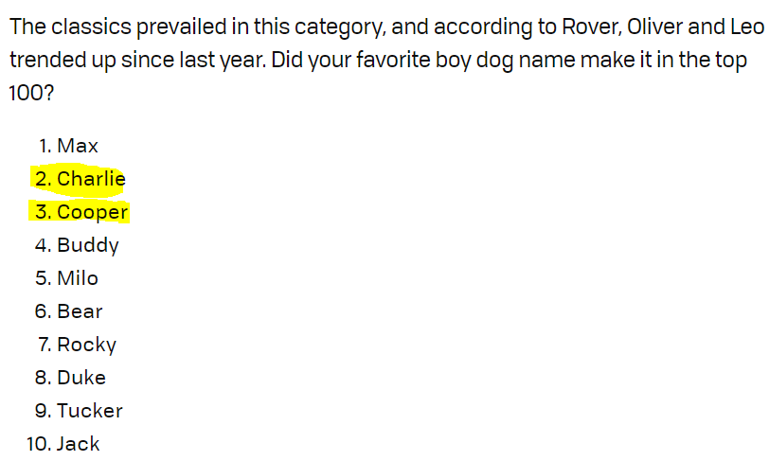

From [www.dailypaws.com](http://www.dailypaws.com)

As shown above Charlie and Cooper are in top 3 of most common dogs in 2020. This shows that our insight is somehow accurate.